2021 Blue, Red, and Burgundy Recital Make-Up Guide
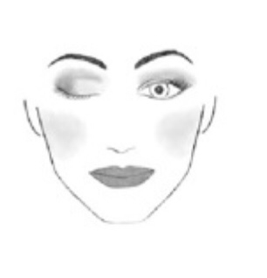
*Example Colors given below. If using other, please make sure they match.

Moisturizer
Blush NYX-Always Punchy
Highlighter for Cheeks- Hard Candy Iridescent Pearl
Lipstick - ELF-Berry Sorbet
Lipliner- to match lipstick
Dark Brown/Black Mascara
Eyebrow pencil or eyeshadow to fill in eyebrows
Liquid Eyeliner: Dark Brown/Black
Eyeshadows-
Example of Colors Needed:
Neutral color for Lid: The City Mini Palette by Maybelline- Brooklynn Nudes
Frost or Pearl White Color- M.A.C White F

Make-up Instructions:

1.Start with a clean moisturized face. Apply primer if possible.
2. Apply blush to the apples of the cheeks and move up toward the cheek bones/ highlight check bones
3. Apply eyeshadow
- Apply the medium eyeshadow to entire lid (flat brush)
- Apply the neutral eyeshadow to eyelid up to your eyebrow. Also apply light eyeshadow to the inside crease of your eye toward the bridge of the nose.
- Apply the dark brown eyeshadow where your eye lid creases and to the outside of the lid. (crease blending brush)
4. Apply dark brown/black eyeliner along the lash line both top and bottom
5.. Apply Mascara to both top and bottom lashes
6. Line the Lips and apply lipstick.

