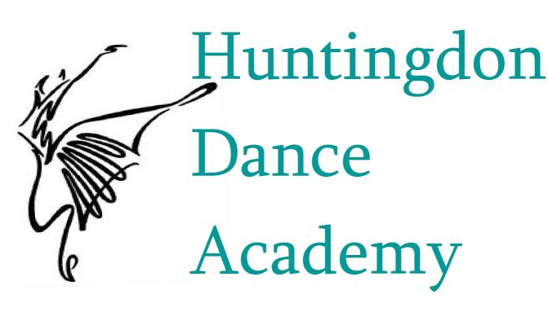
Huntingdon Dance Academy, LLC.
2018–2019 Enrollment Form
Classes Begin - Monday, August 27, 2018

Studio Location: 501 Penn St Huntingdon, PA 16652
Office: 814-506-8243 Kristin Cell: 814-310-1563 Jamie Cell: 814-310-1084
E-mail: registration@huntingdondance.com

Student’s Name: _____________________________________ Age: __________Date of Birth:
Grade level: __________ School Name: _____________________________________________ Gender: M or F
Student’s Address: ______________________________________ City: __________________ Zip:
Student’s home phone: _____________________________ Student’s cell:
Medical concerns that we should be aware of (allergies, injuries, disabilities):

Previous dance experience: Please list dance styles, number of years and dance school attended.
(Only required by students new to Huntingdon Dance Academy)

Parent’s or Legal Guardian’s Name:
Home Phone (if different from student): _______________ Work Phone: _______________ Cell:
E-mail (required): ___________________________________________________________________________
Emergency Contact: ____________________________________ preferred phone:

Name of person responsible for this account (if different from above):________________________________________
E-mail of person responsible for this account (required) (if different from above):

Tuition Rates
Our tuition is based on the dance year (August 27, 2018 – June 15, 2019).
To simplify billing, our yearly tuition is charged in 10 separate installments.
Time/Week | Year/Installment | Time/Week | Year/Installment | Time/Week | Year/Installment | Time/Week | Year/Installment
≤1 hour | $450/$45 | 2.5 hours | $1100/$110 | 4 hours | $1660/$166 | 5.5 hours | $2140/$214
1.25 hours | $560/$56 | 2.75 hours | $1200/$120 | 4.25 hours | $1740/$174 | 5.75 hours | $2220/$222
1.5 hours | $680/$68 | 3 hours | $1300/$130 | 4.5 hours | $1820/$182 | 6 hours | $2300/$230
1.75 hours | $790/$79 | 3.25 hours | $1390/$139 | 4.75 hours | $1900/$190 | 6.25 hours | $2380/$238
2 hours | $900/$90 | 3.5 hours | $1480/$148 | 5 hours | $1980/$198 | 6.5 hours | $2460/$246
2.25 hours | $1000/$100 | 3.75 hours | $1570/$157 | 5.25 hours | $2060/$206 | unlimited | $2500/$250
Yearly tuition paid in full by September 5, 2018, will receive a 5% discount.

Please note when making class selections:
*Students enrolling in Pointe are required to take two ballet classes per week. Students should be evaluated for strength and technique prior to purchasing pointe shoes.
**Students are required take one ballet class per week to enroll in Contemporary, Jazz and/or Modern
***All OUTSTANDING TUITION FROM THE 2017-2018 SEASON MUST BE PAID PRIOR TO REGISTERING FOR 2018-2019

Assigned HDA level__________ Class time/Week__________ Yearly Tuition__________ Installment__________
($20.00 first student & $15 for each additional student) Registration Fee__________
(Please pay September’s installment and registration fee when submitting your registration form.) Total due__________
- Agreement
This agreement is between the customer (parents or guardians of the student) who is responsible for payments and Huntingdon Dance Academy (HDA). By completing this registration and agreeing to its terms, the customer acknowledges that they are legally and financially responsible for the student registered.

- Tuition Commitment
HDA will provide dance instruction for the student beginning August 27, 2018 and ending June 15, 2019. Our tuition is based on the dance year (August 27, 2018 – June 16, 2019). To simplify billing, our yearly tuition is charged in 10 separate installments. The customer agrees to pay the yearly tuition in 10 installments based on the 2018-2019 pricing table that is printed on this registration form. Each installment is due on the 1st day of the month (September – June). Tuition installments not paid by the 5th of the month will be assessed a $15.00 late fee each month they have not been paid. Checks returned for insufficient funds will be assessed a $35.00 “returned check” fee. Families with multiple students receive a 10% discount on the tuition rate for each additional family member. Customers who pay the yearly tuition in full by
September 5, 2018 receive a 5% discount on the tuition rate.

- Costumes
A deposit of $40.00 per recital costume is due by October 15, 2018. The balance of the costume will be due January 15, 2019. Costume deposits and balances not paid by their due dates will be assessed a $15.00 late fee. This costume payment structure is required for us to receive costumes before pictures and to receive the best prices and selections of costumes. Audit classes do not require a costume deposit.
- Injury Release
HDA is not legally responsible for the result of any injury to the student while participating in dance classes or in around the dance studio. It should be understood that although HDA takes every responsible precaution to assure the safety of all students, the parents/guardians and students must assume that risks are involved when participating in dance classes. All students are strongly advised to have health insurance that covers participation in athletic activities. HDA will not be held responsible for any unpaid balance of treatment not covered by your primary insurance carrier. Parents will be notified immediately in the event of an emergency.

- Photography Release (please initial one)
______ I hereby grant Huntingdon Dance Academy, and their respective licensees, successors and assigns, the right and permission, with respect to any media taken of me or the minor named below on whose behalf I am signing, and with respect to any printed or video matter in connection therewith, to do the following:
a. To include such photos or video in all media, and in advertising, publicity and promotion thereof.
b. To use my name or the name of the minor on whose behalf I am signing, in connection with the foregoing.
I hereby release, discharge and agree to indemnify and hold harmless Huntingdon Dance Academy, and their respective heirs, legal representatives, licensees, successors and assigns, from all claims and demands whatsoever arising out of or in connection with the foregoing, and waive any right to inspect or approve the same.

______ I DO NOT grant Huntingdon Dance Academy, and their respective licensees, successors and assigns, the right and permission, with respect to any media taken of me or the minor named below on whose behalf I am signing, and with respect to any printed or video matter in connection therewith, to do the following:
a. To include such photos or video in all media, and in advertising, publicity and promotion thereof.
b. To use my name or the name of the minor on whose behalf I am signing, in connection with the foregoing.
6. Add/Drop Procedure
Students who wish to add or drop a class must complete a “Add/Drop” form. This form must be signed by a parent or guardian and returned to the studio office before the change(s) will take effect. This form must also be completed if a student is withdrawing from HDA. Tuition will continue to be charged at the contracted rate until the completed form is returned to the studio office. The Add/Drop forms are available on our website or in the studio office.

- Important Dates & Policies
HDA lists important dates and additional policies on a separate document entitled, “Important Dates & Policies 2018-19.” These policies are an addendum to this contract and are a part of this contract. The HDA dress code and class descriptions are listed on a separate informational sheet.

- Registration Fee
A registration fee of $20.00 will be charged for the first student in each family registering for class. Additional family members will be charged a $15.00 registration fee.

- Acceptance of Terms
My initials in the box to the left signifies
- I have read and agree to the terms of this contract.
- I have read, received and agree to the policies outlined in the “Important Dates & Policies 2018-19.”

I, _______________________________________________ agree to and understand all information presented in this agreement, release Huntingdon Dance Academy of any claim, damage or suit whatsoever may arise from personal injury or property damages suffered while at Huntingdon Dance Academy and will commit to pay for all classes, costumes, and applicable fees as outlined in this contract.

Signature_______________________________________________ Date________________________________________________

