2021 Recital – Classes Green thru Noir Make-Up Guide
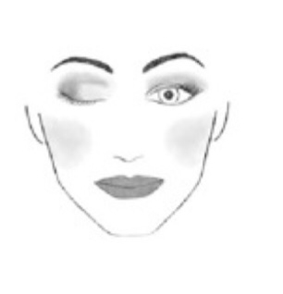
*Example Colors given below. If using other, please make sure they match.

Moisturizer
Face Primer
Eye Shadow Primer (concealer works well)
Foundation to match your skin
Loose or Pressed face powder
Blush M.A.C Mocha or NYX-Amber (a rich rose color)
Highlighter for Cheeks- Hard Candy Iridescent Pearl
Lipstick -M.A.C Russian Red or ELF-Rich Red
Lipliner- to match lipstick
Foundation to match your skin
Dark Brown/Black Mascara
Eyebrow pencil or eyeshadow to fill in eyebrows
Liquid Eyeliner: Dark Brown/Black
False Eyelashes (try the magnetic)-MANDATORY
Eyelash adhesive
Eyeshadows-
Example of Colors Needed:
Neutral color for Lid: The City Mini Palette by Maybelline- Brooklynn Nudes
Frost or Pearl White Color- M.A.C White Frost or L’oreal Petite Pearl
Loose Powder-for setting make up
Setting Spray

Make-up Instructions:

1.Start with a clean moisturized face. Apply primer if possible.
2. Apply foundation making sure you blend into your neck. Make sure you apply foundation to the lids of the eyes or use eyeshadow primer
3. Apply blush to the apples of the cheeks and move up toward the cheek bones/ highlight check bones
4. Apply eyeshadow
- Apply the medium eyeshadow to entire lid (flat brush)
- Apply the neutral eyeshadow to eyelid up to your eyebrow. Also apply light eyeshadow to the inside crease of your eye toward the bridge of the nose.
- Apply the dark brown eyeshadow where your eye lid creases and to the outside of the lid. (crease blending brush)
5. Apply False eyelashes (top only) – magnetic eyelashes instructions are different
- If false eyelashes are too long trim before you apply.
- Apply a thin line of glue on false eyelash.
- Wait a few seconds for glue to become tacky.
- Apply lashes along your own lash line.
6. Apply dark brown/black eyeliner along the lash line both top and bottom
8. Apply Mascara to both top and bottom lashes
7. Apply loose powder all of face. You can also apply a setting spray after to set make-up in place.
8. Line the Lips and apply lipstick.

